**Knowledge Now Corporate Sponsorship Statement of Work**

**Summary:**

We are in the process of looking for ways to increase our revenue stream and possibly expand AAPM&R’s messaging capabilities using Knowledge Now and our corporate sponsors. As a result of this, we are looking to add additional areas on the existing Knowledge Now platform for advertising / recognition space.

**Project Scope:**

* Additional KN Home Page Space: Add extra space to the current widget to the bottom of the page or an additional widget to the bottom of the page for advertising space and support images and embedded video. Additionally, we would like, to have the image adds be able to rotate. These must be editable by AAPM&R.

[Dev] what the size/dimensions should be? Do you need an animated slider type rotator here?

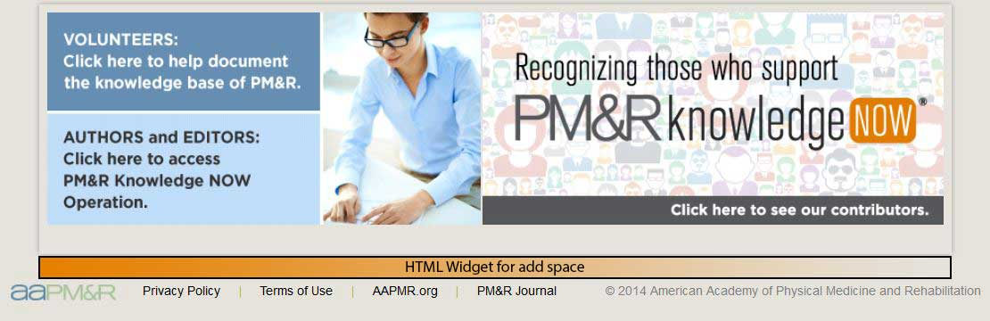

* KN Home Page Tabbed Area Advertising: add a new widget to each of the tabs on the KN home page topics list for advertising space. Like above we would like to have the option for this space to have rotatable images and video support. We would also like to, if possible, divide this space into two widgets. These must be editable by AAPM&R.

[Dev] What kind of videos should be displayed? Can here be needed to embed a youtube/dailymotion video or the video needed to be upload at website location?

* Would it be possible to have the image be dependent on the Category selected? For example: Someone who sponsors Rehabilitation of the Central Nervous System would want to be separate from someone who would sponsor Musculoskeletal Medicine. Essentially each header would have a separate add widget and be able to rotate images.

[Dev] Do you need also animated slider type rotators here? Or the images should be appeared randomly whenever the page view would be appeared.

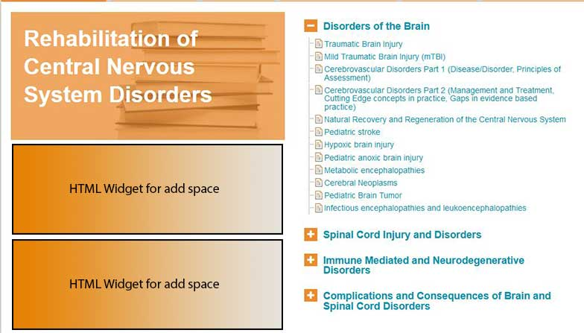

* Category specific advertisements on topic pages: Modify the current widget on topics pages (article.html) so instead of displaying the same advertisement for every topic, it will instead display a different advertisement depending on what category the topic is placed in (Rehabilitation of Central Nervous System Disorders, Musculoskeletal Medicine, Medical Rehabilitation, etc). There will be 6 advertisements altogether (1 for each top-level category). Each topic within a category will share the same advertisement. These advertisements must be editable by AAPM&R staff. Note, if a topic changes categories, the advertisement should update to the ad that would display for the new category. Like in the last area we would like to, possibly, separate this space into two widgets and have support for scrolling images and embedded videos.

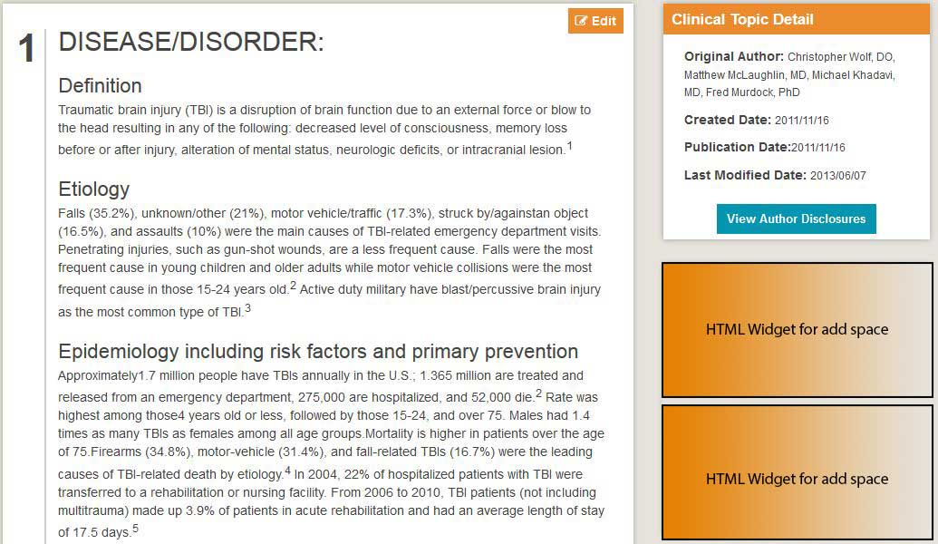

**Non-Advertising Updates**

* Robots.txt file for entire me.aapmr.org website: Update the robots.txt file (<http://me.aapmr.org/robots.txt>) to allow all instead of disallow all. We would like all of the content on our site to be crawled by search engines.
* Related Resources Update: If a user is not logged into the website, add some text to the PM&R Journal section of Related Resources that reads “Please sign in to access PM&R Journal text”.
* Logged in views (ID/Name/Topic(s) viewed): Is there a way to track people who are logged in and what they are viewing? We would like to know the member ID, first / last name and the topic(s) viewed

**Requirements:**

* Must accept HTML (4/5?)
* Must be able to accept jpgs, gif, png
* Must have the ability to cycle / scroll several images (up to 6)
* Must be able to allow for the embedding of videos, which will likely be hosted on YouTube and embedded into the advertising space
* Must be able to be updated by AAPM&R staff

**Timeline:**

* TBD